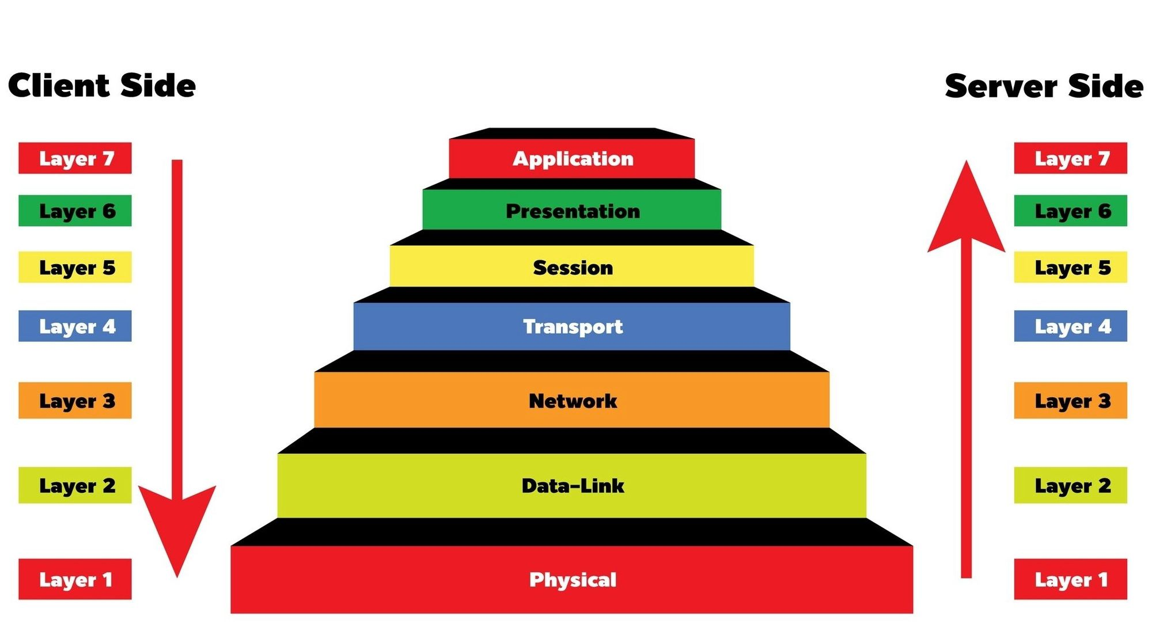

Physical layer = equipment to connect
Ex: USB-ethernet cable, Ethernet cable
Data-Link layer = node-to-node data transfer + MAC address (same LAN = same subnet)
Ex:
+ NAT:
+ BBB (192.168.137.2) interface – PC gateway-enx… (192.168.137.1)
+ PC wifi interface (192.168.1.20) – gateway (192.168.1.1)
+ Bridge:
+ BBB (192.168.1.21) -> PC-ethernet-usb interface->bridge->PC-wifi interface (192.168.1.19) -> gateway (192.168.1.1)

Network layer = forwarding IP packets over different network + IP address (different subnet)
Ex:
+ NAT:
+ PC gateway-enx… (192.168.137.1) - PC wifi interface (192.168.1.20)
+ gateway (192.168.1.1) – Internet network
+ Bridge:
+ gateway (192.168.1.1) – Internet network
Transport layer = end-to-end communication + Port (identify service/application at the destined IP address + different subnet)
Ex:
+ apt update -> send TCP packet to Debian server (use port 80 for HTTP or 443 for HTTPS)

